DANH SÁCH ĐỀ TÀI THỰC TẬP TẠI CÔNG TY TMA SOLUTIONS (https://www.tma.vn/)
Ghi chú: Sinh viên đăng ký qua TS. Lê Văn Quốc Anh (anh@ut.edu.vn) để lập danh sách.

# | Topic Name | Topic Details | Technologies | Number of students
1 | Presentation Support App | Project Objectives:  Today smartphone is so popular to everyone so why we're still using a presentation pen with limitation feature such as: next, previous, laser ray. With the smartphone, we can do more than that.  Project Description:  A mobile application which can be used as a presentation pen in basic mode; for advanced mode, it can support streaming media (slide/image/video) or real-tile drawing/highlight to the presentation screen.  Target:  Phase 1:  + Simple mobile application that can be used as a presentation pen  + Connect to PC by Bluetooth, USB connection  + Single login using QR code, the mobile application can pair with PC by QR  + Navigate slide/image/video which are running on PC  Phase 2:  + Connect to PC via Wi-Fi network/Cloud  + Send streaming slide/image/video from mobile application to PC  + Support multi presentation; user can switch among slide/image/video to show on the screen without interruption  + Support zoom in/zoom out the screen (but the quality is still good)  + Support highlight/tag/recording presentation for review later | Android  .NET  Media streaming  SFTP  Bluetooth  Networking | 2-3
2 | Project daily report | Project Objectives:  To reduce the time of daily meeting, all project status need to be collected for the team to look at without manual work  Project Description:  + Show the status of feature, bug, test progress and milestone  + Get status from email to collect meeting minutes, to be discussed question  + Notify to users if the status is not on-track  + Help leader/manager monitor the status of the team by a single click, single view in one page  Target:  + Admin page that admin user can start/stop/install/remove the monitoring job.  + Each task is a module job, that can be installed by a zip file  + Each task result can support some views (graph/table/list view), and can use them to render in master page/user home page | Front end: Angular/Bootstrap  Backend: .NET  NoSQL Database: MongoDB/ PosgressSQL | 2
3 | Medical Records Tracking with Blockchain | Project Objectives:  There are many problems with current healthcare system such as medical information theft, it also can be tampered, misused, stolen or even lost because of the intermediaries getting access to it and also due to heavy reliance on paper-based documents.  Target:  Build a system (web application) to track medical records. Medical records should be stored on a distributed ledger. It is shared with the patient, healthcare provider, insurer and the government. | - Angular JS, HTML, CSS, Java script  - Restful, Hyperledger Fabric, Composer, NodeJS | 2-3
4 | Manual and automation testing for Element Management System application | Project Description:  Element Management System application provides all the management needs such as configuration, maintenance and troubleshooting operations for telecommunication networks.  Project Objectives:  1. Analyze requirement to create test plan  2. Execute tests, verify and keep tracking bugs  3. Automation tests with Selenium Web Driver and Robot framework. | 1. Software testing.  2. EMS/NMS, SNMP protocol  3. Selenium Web Driver, Robot fwk | 1
5 | Investigate automation framework, automation tools and write automation test script for a web page | Project Description:  Students to investigate Robot framework and Selenium, then write automation test script to validate a provided webpage following data-driven and behavior-driven test.  Project Objectives:  • Understand about Robotframework, Selenium, Data Driven, Behavior Driven.  • Able to compose a test suite with proper startup and tear down  • Flexible in replacing the input values for autoscript  • Suite covers all necessary test scenarios for validating the provided webpage  • Automation log files is easy to read and detect the error with proper screenshot captured. | Robot framework  Selenium  Docker  Data driven testing  Behavior-Driven Development | 2
6 | Virtual Tour | Project Description:  Demand for sightseeing tours is increasingly popular, but not everyone has enough money to travel directly. So virtual tourism is the demand of many people today  Project Objectives:  Build an enhanced virtual reality environment that enables users to visit a location / building / resort with Virtual Reality (VR) glasses  1. Virtual Reality (VR): Using Unity to build a virtual environment allows users to view panoramic maps of places to visit and select the area to visit, then can view details of each area through 360 images  2. Augmented Reality (AR): Support to select map/ area/image by hand movement, recorded through camera and processed inside application  3. 360 Image: Support to view detailed panoramas of the 360 area and can move between images | VR, AR, Unity, 360 Image | 2-3
7 | Overtime Management Tool (OMT) Ver 3.0 | Project Description:  A web app supports managers, members can manage their and their team members extra effort that they spent more every night or weekend. OMT ver 3.0 is the latest version that integrated new technologies to improve performance, security.  Project Objectives:  We need to complete below features:  • Team members can submit and follow their overtime (OT) event.  • Manager can review details and decide to approve/reject/close an OT event.  • Support filters/dashboards.  • Support excel format exporting.  • Trace OT events base on Hyperledger. | Java  MySQL  Spring MVC  Spring Boot  Microservice  Hyperledger – Open Source Blockchain  React  Bootstrap | 2
9 | Smart Hunter | Project Objectives:  Finding enough qualified candidate is always a big challenge to any company, particularly in today’s ultra-competitive job market. Even company invests a lot of money for recruiters and bonus for job introducers but recruitment speed can’t seemingly keep up with ramp-up plan from various programs. Lacking resources is now happening across all of our projects, and it will definitely impact our growth in the future.  This is to create a supportive robot to help us in speeding up our current recruitment progress.  Project Description:  • Provide a list of candidates classified by candidate contacts, qualification, year of experience, …  • Scan a bulk of CVs on webpages like Vietnamworks, Linkedin, Itviec or Social networks  • Analyze CVs fixed with users’ requirement and make the decision whether download CV or not  • The interview invitations to the expected candidates | Machine Learning  Web crawlers  Python  Django/Flash  MongoDB  HTML/CSS/JavaScript  VueJS  Linux | 4
10 | SMART ANIMAL RECOGNITION APP | Project Objectives  It can be hard to keep kids occupied sometimes, especially when school is out. That’s why we typically reach for tablets, phones, or other electronic devices for kids to play with when they are bored or want to explore the world around them.  Smart animal recognition is an app for kids with simple functions to help them discover the world of animals  Project Description  Smart animal recognition provides series of feature to  - Take photos of any animal they see at any time  - Detect and provide the information of animals by the photos taken  - Improve the recognizing result with real time machine learning  - Manage and share animal detected list among users  Project Raw Design  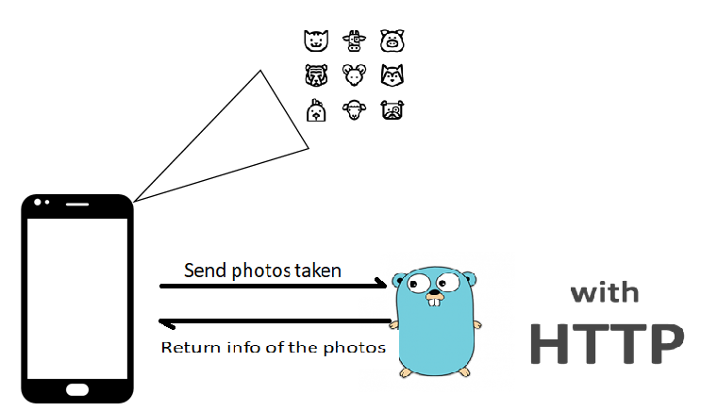 | Machine learning  Go  Tensorflow  Flutter  PosgresSQL | 2-3

